
MERU UNIVERSITY OF SCIENCE AND TECHNOLOGY
DEPARTMENT OF ELECTRICAL AND ELECTRONICS ENGINEERING

BACHELOR OF TECHNOLOGY IN ELECTRICTRAL AND ELECTRONIS ENGINEERING

TITLE: Lab 1 report: Reflector Antenna
EET3422: ANTENNA THEORY & PRACTICE
gro
DATE:25/10/2025

INSTRUCTOR: VICTOR MUTAI.Design and Analyze Curved Reflector Antennas
Group: 3
Group members.
 | Name | Registration Number (in order)
1 | Joshua Muthenya wambua | EG209/109705/22
2 | Wilkister Kwamboka
3 | Nason Alfred
4 | Wayne favour
5 | Akala DAlvan

SOFTWARE: MATLAB R2018a or later
This exercise shows how to design and analyze the curved reflector antennas. Curved reflector antennas are an upgraded version of rectangular reflector antennas. The curved reflector surface of these antennas reflects and focuses the signal, thereby increasing the signal strength.
Some of the notable characteristics of the curved reflectors are high gain, low cross-polarization, and reasonable bandwidth.
This example shows the design and analysis of cylindrical and spherical type curved reflector antennas.
Design and Analyze Cylindrical Reflector Antenna
Cylindrical reflector antenna uses a cylindrical surface as a reflector. This reflector coexists with an antenna in various wireless transmission applications such as radar, general satellite communications, and radio astronomy. The function of the reflector is to focus a beam of signal towards a specific direction for an enhanced antenna gain.
Use the reflectorCylindrical object and its following properties to define the cylindrical reflector and an exciter system.
- GroundPlaneLength-Length of the ground plane in meters
- GroundPlaneWidth-Width of the ground plane in meters
- Depth-Perpendicular distance from origin to cylindrical reflector aperture in meters

GL = 0.3;
GW = 0.3;
D = 0.075;
cref = reflectorCylindrical(GroundPlaneLength=GL, GroundPlaneWidth=GW, Depth=D);
cref.Tilt = 90;
cref.Exciter.TiltAxis = [1 0 0];
cref.Exciter.Tilt = 90;
show(cref)

Paste your Figure here
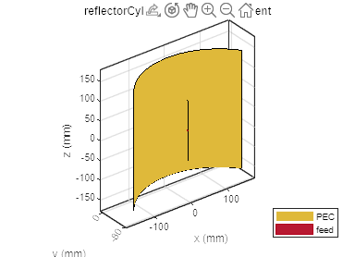

Plot the radiation pattern of the cylindrical reflector at 1 GHz.
pattern(cref,1e9)
view(-26,39)

Paste your Figure here
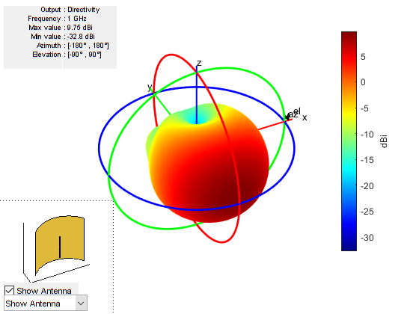

Question
- Indicate the maximum and minimum values of the radiation pattern

Design and Analyze Spherical Reflector Antenna
Create a spherical reflector antenna by taking a cross section from the sphere and suitable for wide-angle scanning. The spherical reflector can provide beam scanning from a fixed reflecting surface without any distortion. This reduces scanning system cost in compared to a conventional reflector antenna systems. The cost reduction comes in eliminating the need to move the primary reflecting surface at all elevation angles. Use the reflectorSpherical objects and the following properties to define a spherical reflector and an exciter system.
- Radius-Radius of the aperture in meters
- Depth-Perpendicular distance between origin and the aperture of the antenna in meters

R = 0.15;
D = 0.15;
sref = reflectorSpherical(Radius=R, Depth=D);
show(sref)

Paste your Figure here

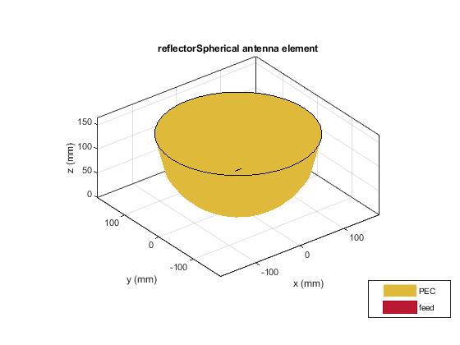

Plot the radiation pattern of the spherical reflector backed dipole at 10 GHz.
pattern(sref,10e9)

Paste your Figure here

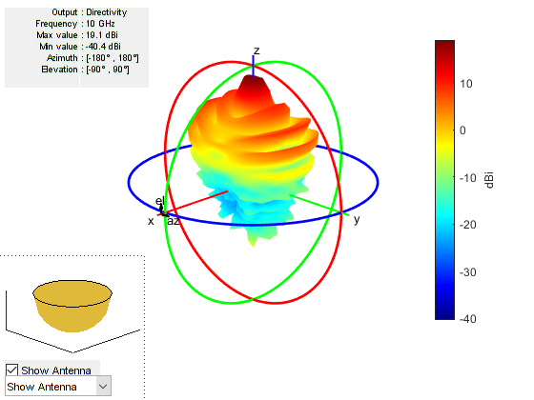
Azimuth Radiation Pattern of Rectangular and Cylindrical Reflector Antennas
Plot the azimuth patterns of rectangular and cylindrical reflector antennas to compare their radiation characteristics.
Create the rectangular reflector antenna object.
antR = reflector;
antR.Tilt = 90;
antR.Exciter.TiltAxis = [1 0 0];
antR.Exciter.Tilt = 90;
show(antR)

Paste your Figure here

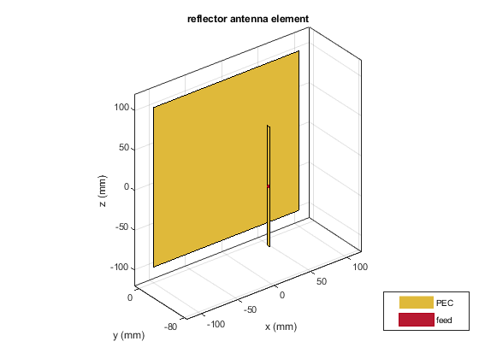

Plot the azimuth pattern plots for the rectangular and the cylindrical reflector antennas and compare their results.
pa1 = patternAzimuth(antR,1e9,0,"Azimuth",0:-1:-360);
pa2 = patternAzimuth(cref,1e9,0,"Azimuth",0:-1:-360);
figure
polarpattern(pa1);
hold on;
polarpattern(pa2);
hold off;
l = legend("Rectangular Reflector","Cylindrical Reflector");
l.Position = [0.6 0.8877 0.2996 0.0869];

Paste your Figure here

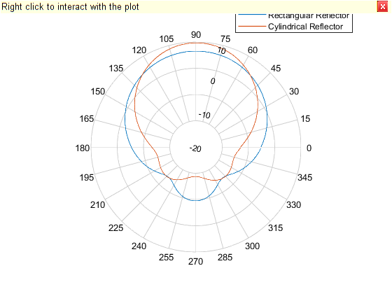

Question
From the figure above, on account of their curvature, which one between cylindrical and rectangular reflector, offer a higher gain?
Elevation Plots of Spherical and Parabolic Reflectors
Plot the elevation patterns of spherical and parabolic reflector antennas to compare their radiation characteristics.
Create a parabolic reflector antenna.
pref = reflectorParabolic;
show(pref)

Paste your Figure here

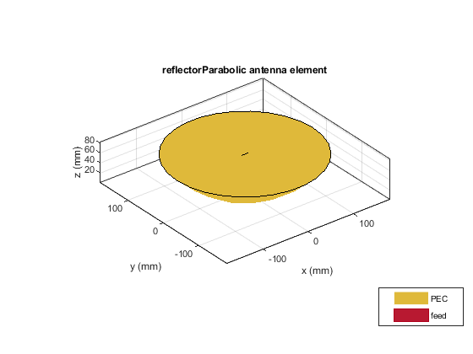
Compare the elevation pattern plots of the parabolic and the spherical reflector antennas.
pe1 = patternElevation(pref,10e9,0,Elevation=0:360);
pe2 = patternElevation(sref,10e9,0,Elevation=0:360);
figure
polarpattern(pe1)
hold on;
polarpattern(pe2)
l = legend("Parabolic Reflector","Spherical Reflector");
l.Position = [0.6 0.8877 0.2996 0.0869];

Paste your Figure here

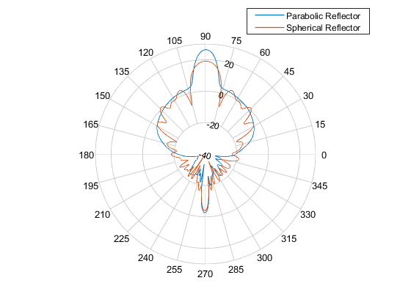

Question
Compare the spherical and parabolic reflector in terms of the number of peaks and what antenna is suitable for scanning a wider area

